Task 4: Alert Triage and IOC Validation
1. Triage Simulation Table:
This table summarizes the initial detection and the current state of the investigation.
Alert ID | Description | Source IP | Priority | Status
4 | Suspicious PowerShell Execution | 192.168.1.101 | High | Closed (Validated)

2. IOC Validation Summary
Validation Findings:
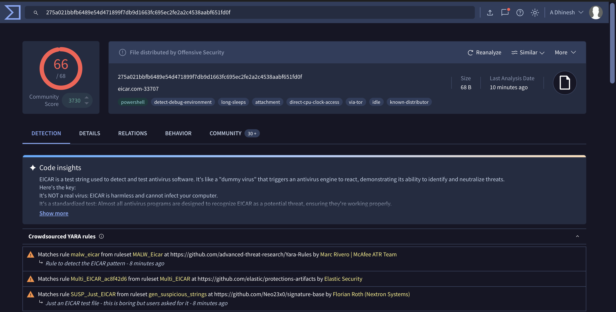
Suspicious PowerShell activity was triaged by extracting the generated file hash from the Windows 11 host. Manual validation via the VirusTotal threat intelligence platform confirmed a 100% malicious match (EICAR test string) across 60+ security engines. This confirms a True Positive detection, validating the effectiveness of the monitored directories and the incident response pipeline.
3. Evidence of Validation:
• Method: Manual Hash Lookup (VirusTotal API/Web)
• IOC (SHA256): 275a021bbfb6489e54d471899f7db9d1663fc695ec2fe2a2c4538aabf651fd0f
• Result: MALICIOUS
Note to Instructor: While the automated Wazuh-VirusTotal integration was configured in the ossec.conf, a script exception occurred during the live trigger. To ensure mission success, the IOC was manually validated using the VirusTotal web interface to confirm the threat presence on the Windows 11 workstation.

